AAA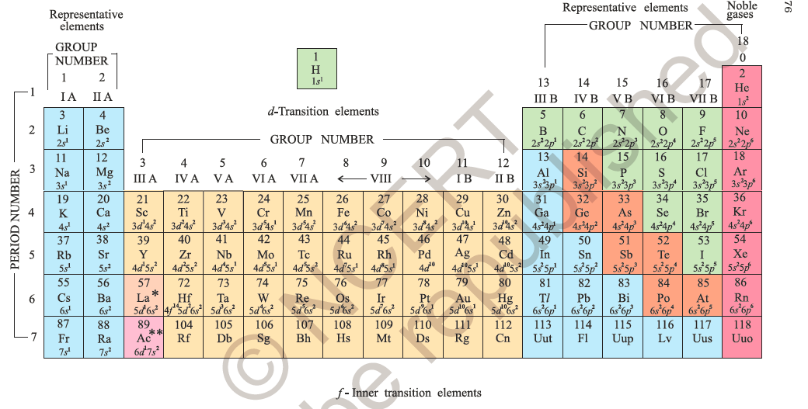

## Q.Define Atomic Radius?

## Ans:Atomic radius is the distance from the centre of the nucleus to the outermost shell containing electrons (IN PARTICULAR SHELL)..

## In other words, it is the distance from the centre of the nucleus to the point up to which the density of the electron cloud is maximum.

## Atomic Radius - Periodicity Project

## Types of Atomic Radii

Atomic radii are divided into FOUR types:

* Covalent radius
* Van der Waals radius
* Metallic
* Ionic radius

### ****1) Covalent Radius****

Covalent radius is one half the distance between the nuclei of two covalently bonded atoms of the same element in a molecule. Therefore, r covalent =  ½ (internuclear distance between two bonded atoms). The internuclear distance between two bonded atoms is called the bond length**.** Therefore,

r covalent =  ½( bond length)

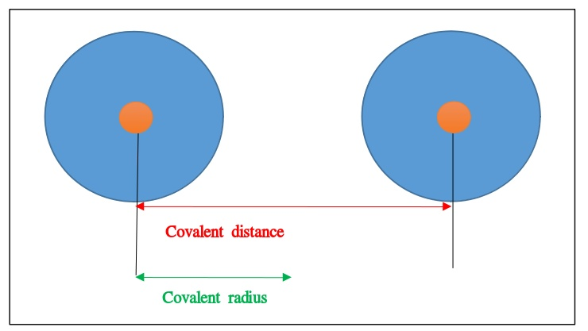

The **Covalent**  decrease with increase in atomic number as we move from left to right in a period because the new electon enters in the same shell and thus nuclear charge increases. And it increases when we move from to to bottom in a group because the increase in effective nuclear charge is overcome by the shielding effect of inner shell electrons. The alkali metals at the extreme left of the periodic table have the largest size in a period.

### ****2) Van der Waals Radius****

It is one half the distance between the nuclei of two identical non-bonded isolated atoms or two adjacent identical atoms belonging to two neighbouring molecules of an element. The magnitude of the Van der Waals radius is dependent on the packing of the atoms when the element is in the solid state.

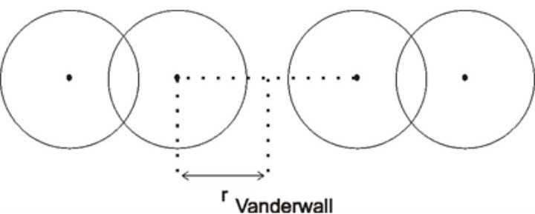

For example, the internuclear distance between two adjacent chlorine atoms of the two neighbouring molecules in the solid state is 360 pm. Therefore, the Van der Waals radius of the chlorine atom is 180 pm.

## ****Q.2 What is theVariation of Atomic Radii in the Periodic Table****

### Variation Within a Period: Variation Within a Period

* The **Covalent** and **Van der Waals** radii decrease with increase in atomic number as we move from left to right in a period. The alkali metals at the extreme left of the periodic table have the largest size in a period.
* As we move from left to right in a period, **nuclear charge** increases by 1 unit in each succeeding element while the **number of shells** remains the same. This enhanced nuclear charge pulls the electrons of all the shells closer to the nucleus. This makes each individual shells smaller and smaller. This result in a decrease of the atomic radius as we move from left to right in a period.
* The **atomic radius** abruptly increases as we move from halogens to the inert gas. This is because inert gases have completely filled orbitals. Hence, the inter-electronic are maximum. We express the atomic size in terms of Van der Waals radius since they do not form covalent bonds. Van der Waals radius is larger than the covalent radius. Therefore, the **atomic size** of an inert gas in a period is much higher than that of preceding halogen

### ****Q.3 What is the Variation Within a Group****

### ****Ans.**** The atomic radii of elements increase with an increase in atomic number from top to bottom in a group. As we move down the group, the principal quantum number increases. A new energy shell is added at each succeeding element. The valence electrons lie farther and farther away from the nucleus. As a result, the attraction of the nucleus for the electron decreases. Hence, the atomic radius increases.

3. Metallic radius: The **metallic radius** is the **radius** of an atom joined by **metallic** bond. The **metallic radius** is half of the total distance between the nuclei of two adjacent atoms in a **metallic** cluster.

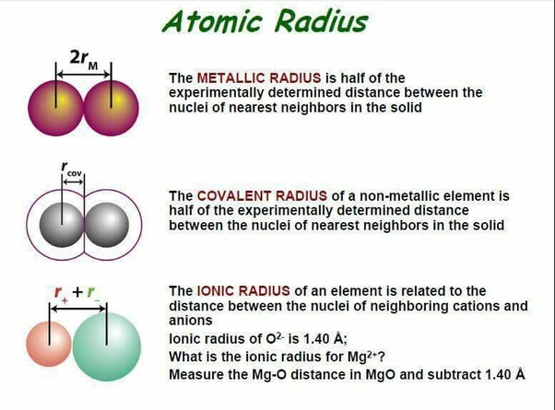

4. Ionic radius: **Ionic radius**, r**ion**, is the **radius** of a monatomic **ion** in an **ionic** crystal structure.